https://github.com/EvanBrown-Git/Essentials/blob/main/DAGV1100and1200/Maya/scenes/Diorama/Diorama9.ma
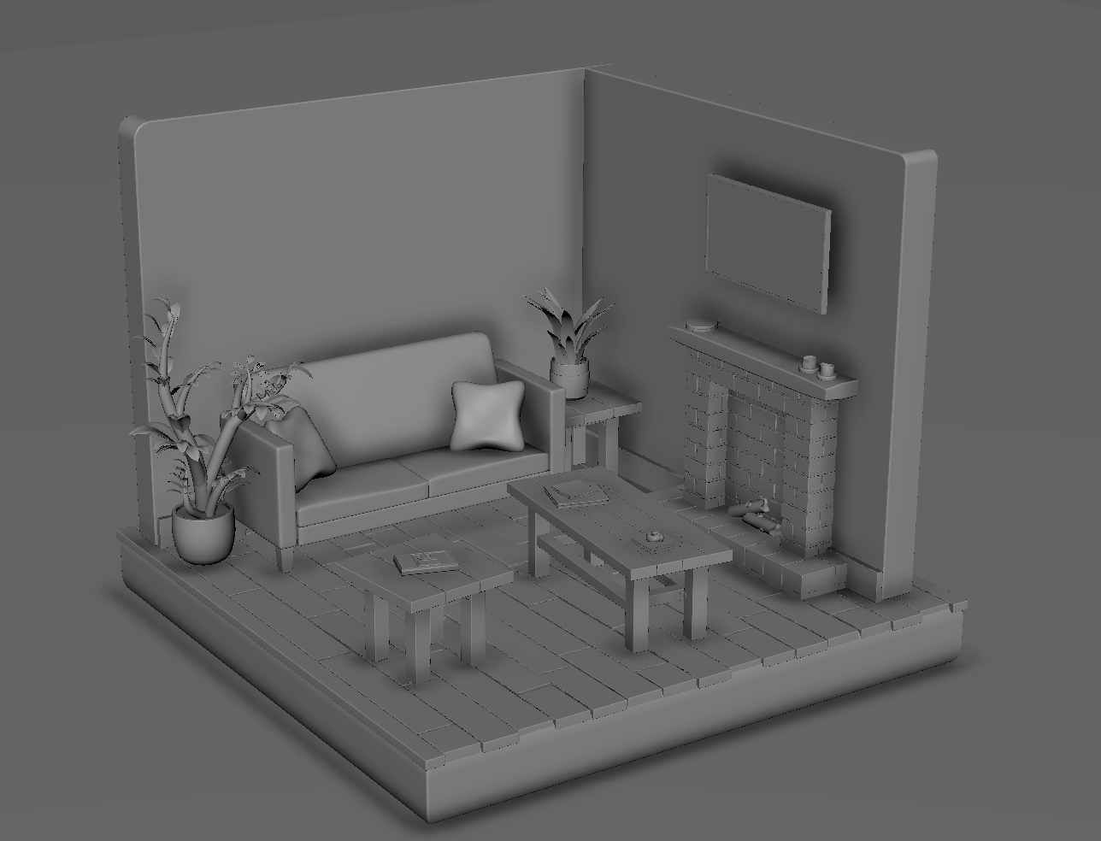

The couch cushions, base, armrests, and back are all cubes with smooth mode and heightened topological density, the feet are cubes. The leafy plant is a bunch of stretched out spheres and manipulated planes. The grassy plant is a bunch of manipulated planes. The flooring is made of cubes. The tables are made of cubes. The answering machine is made of cubes and cylinders. The TV is a heavily manipulated cube. The cinnamon roll is made of two helixes. The tissue under the cinnamon roll was lofted from a pair of Bezier curves. The newspapers are manipulated planes. The candles are manipulated cylinders. The CD player is made of manipulated cylinders. The logs are heavily manipulated cylinders. The bricks are cubes. The pots and dirt in the pots are manipulated cylinders. The walls are cubes, the baseboards are cubes.

